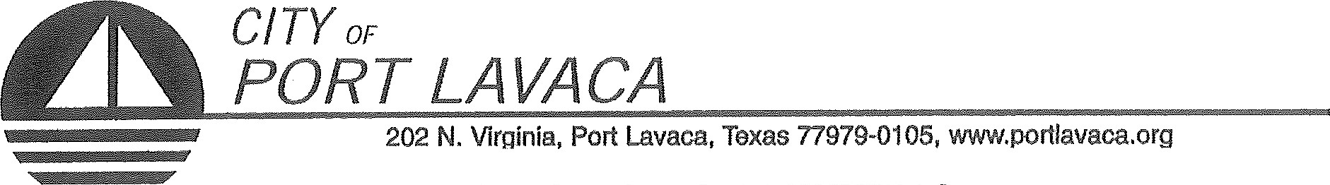
PUBLIC NOTICE OF MEETING
PUBLIC NOTICE IS HEREBY GIVEN THAT THE PORT COMMISSION OF THE CITY OF PORT LAVACA TEXAS WILL HOLD ITS REGULAR MEETING TUESDAY, FEBRUARY 20, 2018
BEGINNING AT 10:00 A.M. AT THE REGULAR MEETING PLACE IN COUNCIL CHAMBERS IN CITY HALL, 202 NORTH VIRGINIA STREET, PORT LAVACA, TEXAS TO CONSIDER AND TAKE ACTION ON THE FOLLOWING ITEMS OF BUSINESS:
- CALL TO ORDER
- COMMENTS FROM THE PUBLIC
(Limited to 3 minutes per individual unless permission to speak longer is received in advance)
AGENDA: (PORT COMMISSION WILL CONSIDER/DISCUSS THE FOLLOWING ITEMS AND TAKE ANY ACTION INCLUDING CALLING FOR A CLOSED SESSION ON ANY OF THE BELOW ITEMS AS DEEMED NECESSARY.)
- PRESENT NEW PORT COMMISSIONER, RAYMOND BUTLER.
- CONSENT AGENDA:
  - MINUTES OF REGULAR MEETING JANUARY 16, 2018.
  - MINUTES OF WORKSHOP FEBRUARY 12, 2018.
- REPORTS
  - TARIFF REPORT
  - ACCOUNT AGING REPORT
  - REVENUE AND EXPENDITURE REPORT
  - BALANCE SHEET
  - PAYMENT REPORT
  - ACCOUNT MASTER REPORT
- RECEIVE REPORTS FROM STAFF REGARDING HARBOR OF REFUGE.
- DISCUSS AND TAKE NECESSARY ACTION ON HELENA CHEMICAL HARBOR OF REFUGE LEASE. DISCUSS AND/OR TAKE ANY ACTIONS NECESSARY.
- RECEIVE REPORTS FROM STAFF REGARDING CITY HARBOR.
- DISCUSS THE STATUS OF EVELYN’S FISH MARKET. DISCUSS AND/OR TAKE ANY ACTIONS NECESSARY.
- RECEIVE REPORTS FROM STAFF REGARDING NAUTICAL LANDINGS MARINA AND BOATS. DISCUSS AND/OR TAKE ANY ACTIONS NECESSARY.
- RECEIVE REPORTS FROM STAFF REGARDING NAUTICAL LANDINGS BUILDING. DISCUSS AND/OR TAKE ANY ACTIONS NECESSARY.
- RECEIVE RECOMMENDATIONS FROM HARBOR MASTER REGARDING NECESSARY RULES AND REGULATIONS IN NAUTICAL LANDINGS MARINA DAY ROOM. DISCUSS AND TAKE ANY ACTION NECESSARY.
- REVIEW BUDGET MANAGEMENT POLICY. DISCUSS AND TAKE ANY ACTIONS NECESSARY.
- RECEIVE REPORTS FROM CITY ENGINEER AND URBAN ENGINEERING ON RECOMMENDATIONS FOR IMPROVEMENT AND REFERRALS FROM CITY COUNCIL. DISCUSS AND TAKE ANY ACTIONS NECESSARY.
- GENERAL COMMENTS FROM COMMISSION.
ADJOURN

ALEX DAVILA, CHAIRMAN
PORT COMMISSION

CERTIFICATION OF POSTING NOTICE
THIS IS TO CERTIFY THAT 'THE ABOVE NOTICE OF A REGULAR MEETING OF THE PORT COMMISSION OF THE CITY OF PORT LAVACA TO BE HELD TUESDAY, DECEMBER 19, 2017BEGINNING AT 10:00 A.M., WAS POSTED AT CITY HALL, EASILY ACCESSIBLE TO THE PUBLIC, AS OF 5:00 PM, FRIDAY, FEBRUARY 16, 2018.
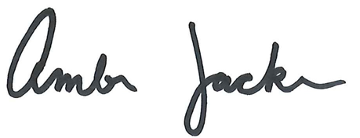

BY:_________________________________________________
AMBER JACKSON
ADMINISTRATIVE ASSISTANT
The Port Lavaca City Hall and Council Chambers are wheelchair accessible. Access to the building is available at the primary north entrance facing Mahan Street. Special parking spaces are located in the Mahan Street parking area. In cornpliance with the Americans with Disabilities Act, the City of Port Lavaca will provide för reasonable accommodations for persons attending Port Commission meetings. To better serve you, request should be received 24 hours prior to the rneetings. Please contact City Secretary Mandy Grant at (361) 552-9793 Ext. 23() for assistance.

