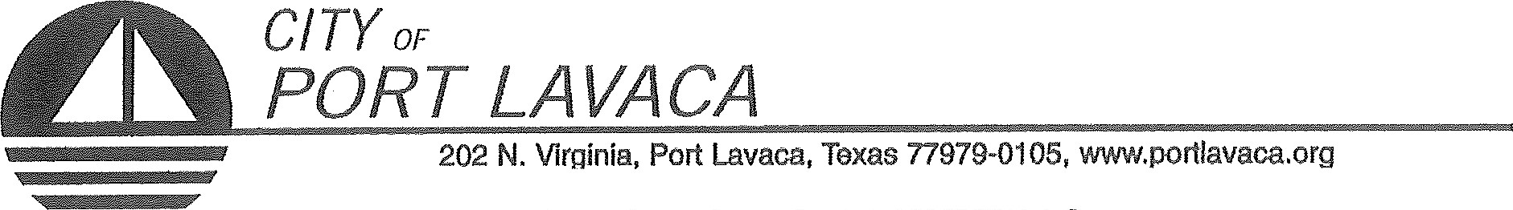
PUBLIC NOTICE OF MEETING
PUBLIC NOTICE IS HEREBY GIVEN THAT THE PORT COMMISSION OF THE CITY OF PORT LAVACA TEXAS WILL HOLD A WORKSHOP MONDAY, FEBRUARY 12, 2018 BEGINNING AT 8:30 A.M. AT THE REGULAR MEETING PLACE IN COUNCIL CHAMBERS IN CITY HALL, 202 NORTH VIRGINIA STREET, PORT LAVACA, TEXAS TO CONSIDER AND TAKE ACTION ON THE FOLLOWING ITEMS OF BUSINESS:

- CALL TO ORDER
  - ANNOUNCEMENT BY CHAIRMAN THAT WORKSHOP SESSION NOW OPEN
- CONDUCT WORKSHOP SEESION:
- RECEIVE AND DISCUSS ACCOUNTS RECEIVABLE, REVENUE, AND ACCOUNTING PROCEDURES WITH CITY AUDITORS.
ADJOURN

ALEX DAVILA, CHAIRMAN
PORT COMMISSION

CERTIFICATION OF POSTING NOTICE
THIS IS TO CERTIFY THAT 'THE ABOVE NOTICE OF A REGULAR MEETING OF THE PORT COMMISSION OF THE CITY OF PORT LAVACA TO BE HELD MONDAY, FEBRUARY 12, 2018BEGINNING AT 8:30 A.M., WAS POSTED AT CITY HALL, EASILY ACCESSIBLE TO THE PUBLIC, AS OF 5:00 PM, FEBRUARY 8, 2017.
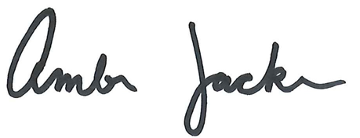

BY: _________________________________________________
AMBER JACKSON
ADMINISTRATIVE ASSISTANT
The Port Lavaca City Hall and Council Chambers are wheelchair accessible. Access to the building is available at the primary north entrance facing Mahan Street. Special parking spaces are located in the Mahan Street parking area. In cornpliance with the Americans with Disabilities Act, the City of Port Lavaca will provide för reasonable accommodations for persons attending Port Commission meetings. To better serve you, request should be received 24 hours prior to the rneetings. Please contact City Secretary Mandy Grant at (361) 552-9793 Ext. 23() for assistance.

